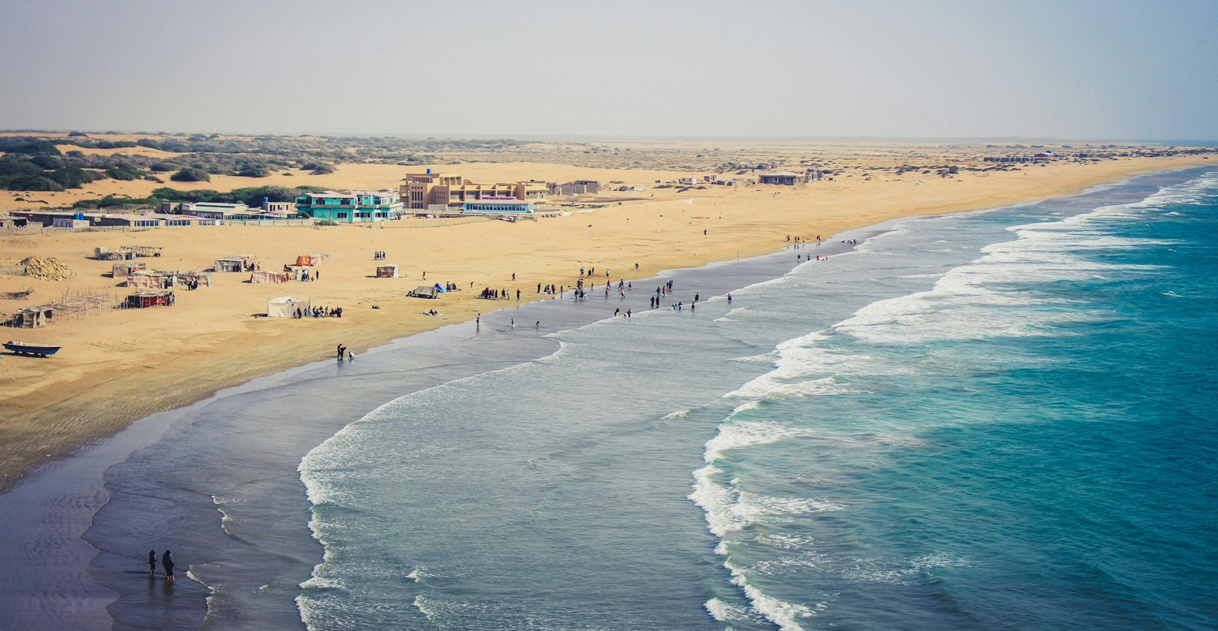

**KUND MALIR**

**BEACH**

**Discover the Pristine Beauty of Kund Malir**

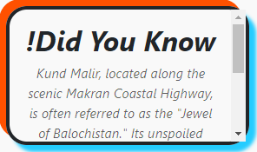Nestled along the stunning Makran Coastal Highway, Kund Malir is a serene gem that offers breathtaking landscapes and unspoiled natural beauty. This tranquil beach is famous for its golden sands meeting the turquoise waters of the Arabian Sea. Far from the hustle and bustle of city life, Kund Malir is a sanctuary for travelers seeking peace and solitude. With its untouched environment, it has become a must-visit destination for nature lovers and adventurers exploring Balochistan's coastal wonders.

**A Coastal Paradise on the Makran Coastal Highway**

Kund Malir is often hailed as one of the most picturesque

spots along the iconic Makran Coastal Highway. Surrounded by rocky mountains and endless blue waters, it’s a perfect retreat for those who love scenic drives and mesmerizing ocean views. The journey to Kund Malir is as captivating as the destination itself, with winding roads and panoramic landscapes that leave visitors spellbound. This beach is not just a destination; it's a gateway to experiencing the raw, untouched beauty of Balochistan's coastline.

**Kund Malir: A Tranquil Escape for Adventure Seekers**

For adventure enthusiasts, Kund Malir offers the perfect mix of excitement and relaxation. The beach is ideal for activities like camping under the starlit sky, enjoying bonfires by the shore, or simply soaking in the tranquility of nature. The nearby Hingol National Park adds to the allure, with its unique rock formations, wildlife, and the mystical Hinglaj Mata Mandir, making Kund Malir a hub for exploration and cultural discovery.

**Experience the Serenity of Balochistan at Kund Malir**

Kund Malir stands out as a hidden treasure, offering an unparalleled sense of serenity and connection with nature. The pristine environment, free from urban distractions, allows visitors to disconnect from their daily routines and rejuvenate their minds. Whether it's the calming sound of waves, the breathtaking sunsets, or the untouched sands, Kund Malir encapsulates the essence of Balochistan's natural beauty, making it a must-visit destination for those seeking a peaceful getaway.

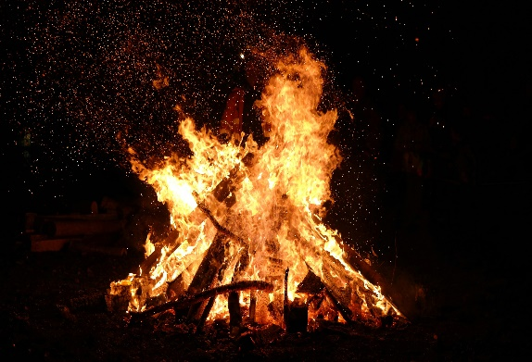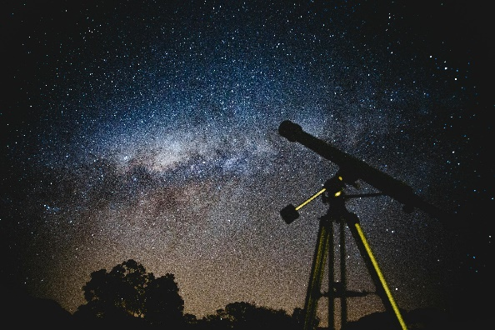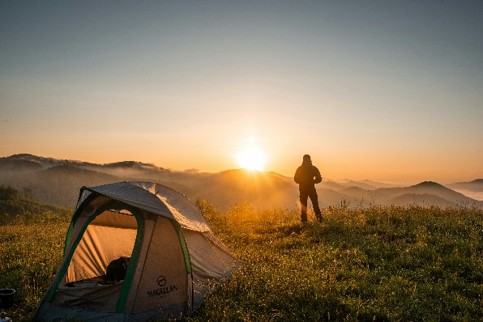***ENJOYABLE ACTIVITIES***

***! STARGAZING The clear night sky offers an incredible opportunity to admire the stars and constellations.***

***! BONFIRE NIGHT Gather around a bonfire, roast marshmallows, and share stories with friends and family.***

***! BEACH CAMPING Set up a tent under the stars and enjoy the peaceful ambiance of the beach at night.***

**Discover the Untouched Paradise of Kund Malir**

Kund Malir, nestled along the Makran Coastal Highway in Balochistan, is a pristine and serene destination that feels like a slice of paradise away from urban chaos. Known for its golden sands, crystal-clear waters, and an unspoiled environment, it is a haven for nature enthusiasts and travelers seeking tranquility. This hidden gem is surrounded by majestic mountains and vast desert landscapes, creating a breathtaking contrast against the azure sea. Free from commercialization, Kund Malir offers visitors the rare opportunity to immerse themselves in the raw beauty of nature, making it a must-visit for anyone looking to escape into peace and solitude.

**Kund Malir: A Coastal Retreat of Tranquility and Adventure**

* A Beach Beyond Compare:

Kund Malir is not just another beach—it’s a harmonious blend of natural beauty and serenity. With its pristine shoreline and golden sands, it stands as a perfect getaway for those who seek peace away from the city’s hustle and bustle.

* The Calming Sound of Waves:

The rhythmic crashing of waves against the shore creates an ambiance of calmness, offering visitors a therapeutic escape from their daily stresses.

* Untouched Natural Beauty:

Unlike commercialized beaches, Kund Malir remains largely untouched, retaining its raw, unspoiled charm. Its cleanliness and lack of urban distractions make it an ideal destination for those looking to reconnect with nature.

* A Haven for Adventure Seekers:

While its tranquility is unmatched, Kund Malir also caters to adventurers. Visitors can hike through the nearby cliffs and rugged landscapes, adding an element of thrill to their journey.

* Gateway to Hingol National Park:

Kund Malir is located near Hingol National Park, one of the largest and most breathtaking reserves in Pakistan. Here, you can witness diverse wildlife, scenic beauty, and geological marvels, making the trip even more rewarding.

* Marvel at the Princess of Hope:

A short drive from Kund Malir takes you to the iconic "Princess of Hope" rock formation. This natural sculpture, carved over centuries by wind and water, stands as a testament to nature’s artistic prowess.

* A Photographer’s Paradise:

With its stunning landscapes, from the vibrant blue waters of the Arabian Sea to the dramatic backdrop of rugged mountains and desert terrain, Kund Malir offers countless opportunities for photographers and nature lovers alike.

* Mesmerizing Sunsets:

The sunsets at Kund Malir are nothing short of magical. As the sun dips below the horizon, the sky transforms into a canvas of fiery oranges and soft purples, creating unforgettable views for visitors.

* An Unforgettable Stargazing Experience:

The absence of city lights makes Kund Malir one of the best spots for stargazing in Pakistan. On clear nights, the sky is illuminated with countless stars, offering an enchanting view of the cosmos.

* Perfect for Family and Friends:

Kund Malir’s peaceful environment, coupled with opportunities for exploration, makes it an ideal destination for a day trip or an overnight camping adventure with loved ones.

***Whether you’re drawn to its calm and soothing environment or the thrill of exploring nearby attractions, Kund Malir offers an experience that’s both rejuvenating and adventurous. This coastal retreat truly embodies the essence of Balochistan’s untamed beauty, leaving every visitor with memories to cherish for a lifetime.***

**LOCATION**

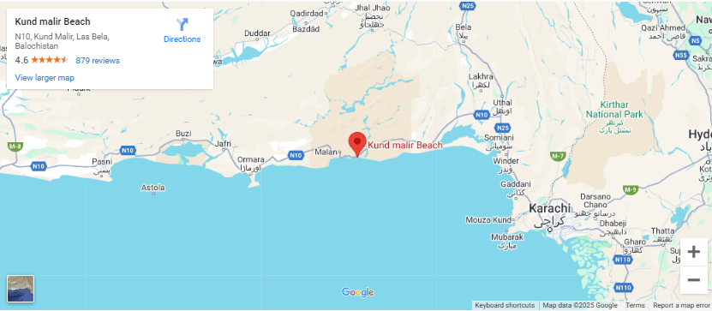

Kund Malir is located in the Hingol National Park, Balochistan, Pakistan, along the Makran Coastal Highway. It's a beautiful, remote beach known for its stunning landscapes and clear waters.

**Why Visit Kund Malir Beach?**

**Kund Malir Beach is a hidden paradise nestled along the Makran Coastal Highway in Balochistan, offering a unique blend of natural beauty and serenity. Unlike commercialized tourist spots, Kund Malir remains untouched, making it a must-visit destination for nature enthusiasts, adventurers, and peace-seekers alike. Here’s why Kund Malir Beach deserves a place on your travel.**

**FEATURED PRODUCT**









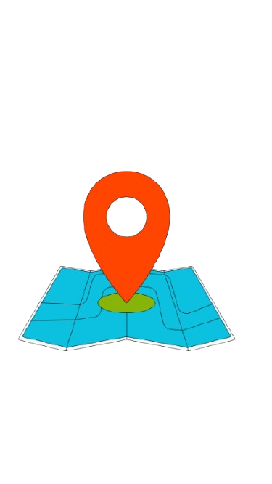**SHOP LOCATION**

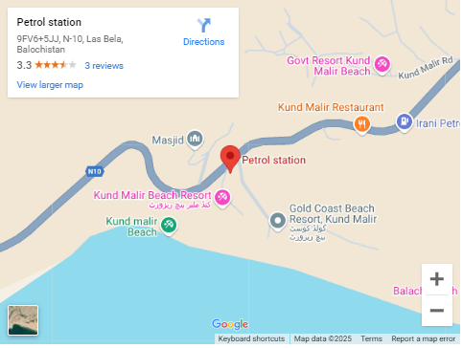

The petrol stations in Lasbela, Balochistan, are located along the main highways, particularly the Makran Coastal Highway (N-10) and the national routes passing through the area. Lasbela is about 120 km east of Karachi.